
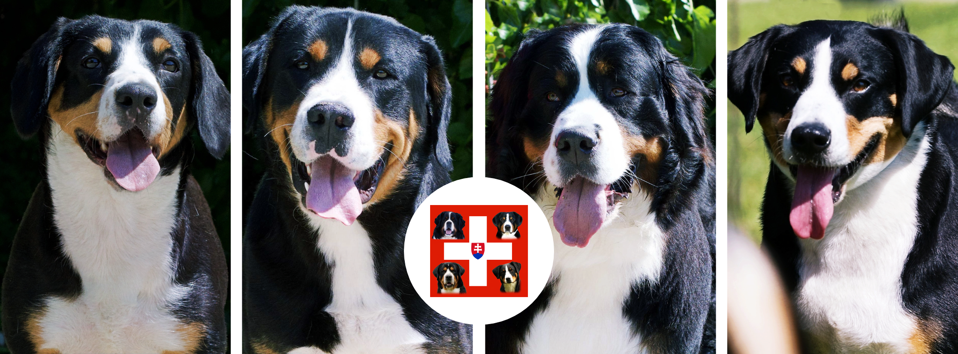


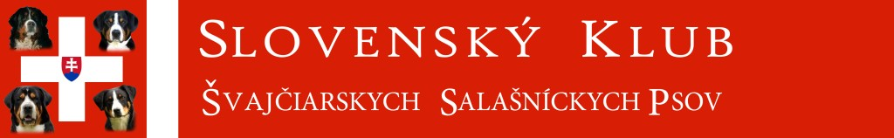
you are cordially invited to our

Specialty Show

With awarding

CAJC SR, CAC SR,
Specialty Winner 2026, Specialty Junior Winner 2026 Specialty Veteran Winner 2026,
BOJ, BOV, BOB, BOS

For breeds: Appenzell cattle dog, Bernese mountain dog, Entlebuch cattle dog, Great swiss mountain dog

which will be held on:
September 26th2026
Plauter Kúria Hotel area, Veľký Meder

Judges: Jan HERNGREN (SWEDEN) BMD, ESP, APZ, GSMD
*In the event of an increased number of applications, a Slovak judge will be appointed.

Schedule: 8.00 – 9.00 Entering the dogs
9.30 Judging in the rings

Entry close: 01.09.2026 - 1. closing date
11.09.2026 - final closing date

Entry registration:

ONLINE ENTRY ONLY: www.clubdogshow.sk
Email address: vystavy.skssp@gmail.com
Contact: Ing. Tibor Križan, Fučíkova 1554/2, 932 01 Veľký Meder, SK

Entry fees:  klubu | Club members * | No club membership
1st dog ** | 30 € | 50 €
2nd dog and others | 25 € | 45 €
Minor puppy class | 5 € | 10 €
Puppy class | 5 € | 10 €
Veteran class | 0 € | 0 €
Honorary class | 10 € | 20 €
Competitions *** | 10 € | 20 €
Final close | + 5 € | + 10 €

*A dog owner is considered a member of the club if his/her application to the club is accepted by the club committee no later than on the 1st closing date.
**In the case of multiple entries, dogs entered in the Junior, Junior, Veteran and Honor classes are not considered as 1st entries.
***The Best Stud Dog, Best Brood Bitch, The best Breeder’s group competitions can be entered at the show in the show office or in advance by contacting our clubdogshow administrator via email: jaro04@zoznam.sk

Fees should be paid to: IBAN: SK 19 1100 0000 0029 2186 1031
SWIFT/BIC: TATRSKBX
Address of the bank: Tatra banka, Hodžovo nám.3, Bratislava
Variable symbol: you will receive it after your the dog is registred in clubdogshow
online system****

Account name: Slovenský klub švajčiarskych salašníckych psov

Address: Fučíkova 1554/2, 932 01 Veľký Meder, Slovakia
Notes:
****When paying entry fees, it is necessary to state the variable symbol from the confirmation of entries, which the owner will receive by e-mail from the online system immediately after the dog is registered for the show. Write the name of your dog into a payer’s reference, please.
Cash payment at the show is NOT possible.
CLASSES
Minor puppy class correctly inoculated puppies up to 6 months
Puppy class 6 - 9 months
Junior class 9 - 18 months
Intermediate class 15 – 24 months
Open class 15 months and over
Champion class 15 months and over (Championship certificate compulsory)
Honorary class for dogs with titles Interchampion, Champion, National and Club winner
(Title certificate compulsory). This class is out of competition and winners are
not awarded by CAC. Winners of honour class with "Excellent 1" compete
in the finals in own competition.
Veteran class 8 years and over
TITLES
CAJC SR Certificate for the Junior Champion title of Slovakia may be awarded to dogs and bitches graded as Excellent 1st in junior class
CAC SR Certificate for the Champion of Slovakia may be awarded to dogs and bitches graded Excellent 1st in intermediate, open or champion class
Reserve CAC SR may be awarded to dogs and bitches graded as Excellent 2nd in intermediate, open or champion class
Specialty Junior Winner 2026 may get males and females with valuation of Excellent 1, CAJC.
Specialty Veteran Winner 2026 may be awarded to dogs and bitches graded Excellent 1st in veteran class
Specialty Winner 2026 may get the best male and best female with valuation of Excellent 1 CAC
Best junior in breed (BOJ) awarded to best male or female that was honoured with CAJC title
Best of Veterans (BOV) A male and a female dog of the same breed, both holding the title Veteran Winner of the Special Show, are entering the competition.
Best of Breed (BOB) The Specialty Junior Winner, The Specialty Winner and The Specialty Veteran Winner from both sexes, if awarded Excellent 1, will compete for Best of Breed.
Best of Opposite Sex (BOS) The Specialty Junior Winner, The Specialty Winner and The Specialty Veteran Winner, the best exhibit from the opposite sex
Best Minor Puppy Competition for all males and females, qualified Very promising 1 in Minor Puppy class in regular judging. Males and females as well as all breeds compete together
Best Puppy Competition for all males and females qualified Very promising 1 in Puppy class in regular judging. Males and females as well as all breeds compete together
BIS Veteran may be awarded to a male or female awarded with BOV title, all breeds together
BIS Honour Class may be awarded to a male or female awarded with Excellent 1 from honour class of all breeds
BIS Junior awarded to best male or female that was honoured with BOJ title, all breeds together.
Best in Show (BIS) for all males and females awarded with BOB
COMPETITIONS
Best Brace The owner can enter his male and female of the same breed that have been judged in the Club Show. They are owned by a single owner, not a co-owner. The owner must be listed in the pedigree certificate. May only be awarded to a couple that possesses the typical features of its reed which are well-balanced and both dogs have the typical features of their sex
The best Breeder’s group: Breeder can enter his breeder´s group of at least 3 – max 5 dogs and or bitches of the same breed,
colour and size which have been judged in that club show. The dogs do not have to be owned by
breeder, but they must come from the same kennel from at least two different litters, at least two
different sires and dams. A dog /bitch can only be entered to one breeder´s group. Exhibitors are
obliged to let their dogs compete in this competition when asked by the breeder.
Child and Dog Open competition for all children up to 9 years and dogs judged at this club show. There will judged the harmony and cooperation between the child and the dog.
Junior Handling Competition for all junior handlers and dogs is divided into two categories: the1st category: 9-13 years, the 2nd category: 14-17 years. The main aim of junior handling competitions is to increase the youth’s interest in canine activities and promote and develop the co-operation and contacts between dogs and the young people. The quality of a dog will not be judged there, but the handling.
Best Stud Competition for stud dogs with at least three offsprings of two dams that have been judged at this club show. There will be judged a type and quality of their offsprings. A stud dog does not have to be judged in competition.
Best Brood Bitch the brood bitch and at least three offsprings of two sires. There will be judged a type and quality of a brood bitch´s offsprings. The brood bitch does not have to be judged in competition
GENERAL TERMS
- The show is held under the FCI and SKJ show regulations.
- Only dogs registered with the stud books recognised by the FCI can enter the show.
- Dogs entered into Minor puppy or Puppy class must have at the time of sending application form valid pedigree, the same is for imported dogs.
- A copy of the pedigree must be enclosed to each application.
- In case of a wrong class on the entry form, the dog will be automatically entered in the correct class according to his age, any dog older than 15 months will in this case be entered in the open class.
- Applications lacking any necessary document (a copy of the Championship certificate for the champion class and a copy of a title awarding for the honorary class) will be automatically entered into the open class without notifying owners.
- The exhibitor commits to pay the exhibition fees even when he/she will not take part at the show.
- Should the show not be held for the unforeseen reasons, the exhibition fees will be used to cover the expenses.
- The organiser may refuse to accept the application without stating the reason.
- The organiser cannot be held responsible for damages caused by/to a dog.
- The owner is responsible for any damages caused by the dog.
- The exhibitor is responsible for the well-being of his dog at the show – he must not expose him to situations that could endanger his health or even his life, e.g., leave it in the car in extreme winter or heat or treat it cruelly. Anyone who violates these principles can be excluded from this show.
- The exhibitor by entering the dog for the show as a person concerned in accordance with § 13 of Act no. 18/2018 Coll. on the protection of personal data, gives its consent to the organizer for the processing of his personal data (name, surname) and agrees to their publication (name, surname), photo documentation and results of the show on the organizer’s website.
- Changes in judges list reserved.

VETERINARY REGULATIONS
Dogs from abroad must have a PET PASSPORT with valid vaccinations. We would like to ask and recommend that dogs have a vaccination against kennel cough.
ACCOMMODATION
Veľký Meder , www.plauterkuria.sk/Velky-Meder/hlavnastrana.php
PROTEST
The protest can be submitted only for formal reasons, in a writing form at the exhibition office, during the exhibition, until the end of the assessment in rings at the same time with the deposit of 50 €, which will be forfeited if the exhibitor is against. Protest against the judge’s decision of the judge (referee), against the award, the awarded title, etc. is not allowed.

